## Changes in activiti (5.21.0) workflow source code

1. Added new file **entity-selector.js** in **modules\activiti-webapp-explorer2\src\main\webapp\editor-app** folder
2. Modified modules\activiti-webapp-explorer2\src\main\webapp\**modeler.html**

Add <script src="editor-app/entity-selector.js" type="text/javascript"></script> below <script src="editor-app/app.js"></script>

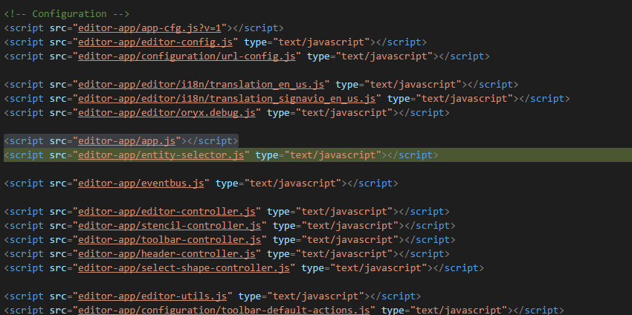

1. Modified modules\activiti-webapp-explorer2\src\main\webapp\editor-app\configuration\properties\**form-properties-popup.html**
   1. Added **<option>entity</option>** and **<option>api</option>** to typeField select box options

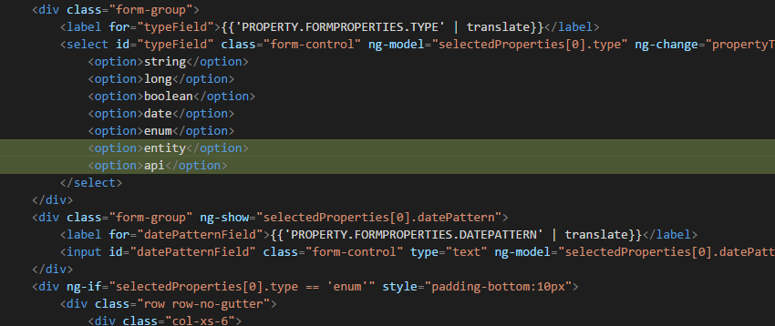

* 1. Added below code to handle the above options (entity and api) just above expressions and variable fields

<div ng-if="selectedProperties[0].type == 'entity'">

<rt-entity-selector selected-module-id="selectedProperties[0].customModuleId" selected-entity-type-id="selectedProperties[0].customEntityTypeId" selected-entity-id="selectedProperties[0].expression">

</rt-entity-selector>

</div>

<div ng-if="selectedProperties[0].type == 'api'">

<rt-entity-api-selector selected-module-id="selectedProperties[0].customModuleId" selected-entity-type-id="selectedProperties[0].customEntityTypeId" selected-api-id="selectedProperties[0].expression">

</rt-entity-api-selector>

</div>

* 1. Added **ng-if** to conditionally show expression and variable fields (Hide expression variable fields when either option of type **entity** or **api** is selected)

ng-if="selectedProperties[0].type != 'entity' && selectedProperties[0].type != 'api'"

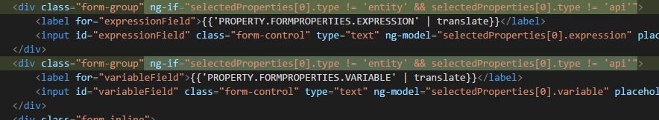

1. Modified modules\activiti-webapp-explorer2\src\main\webapp\editor-app\**app-cfg.js** to have app level reactore specific configuration settings

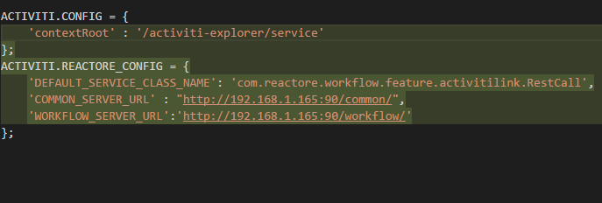

1. Modified modules\activiti-webapp-explorer2\src\main\webapp\editor-app\**stencil-controller.js** to set default value for property **'oryx-servicetaskclass'**

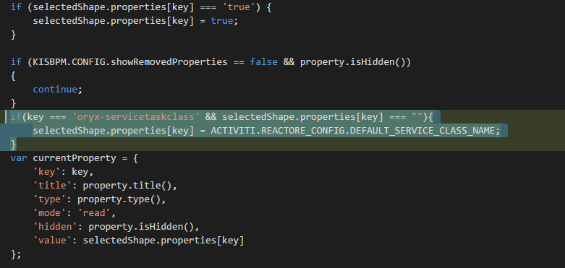

1. Modified **properties-form-properties-controller.js**
   1. Injected rtEventsService into KisBpmFormPropertiesPopupCtrl as a dependency

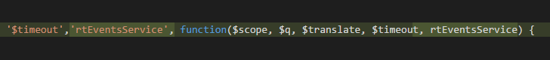

* 1. Added subscription for topic “onApiSelected” and listener for $destroy on scope for unsubscribing the “onApiSelected” subscription

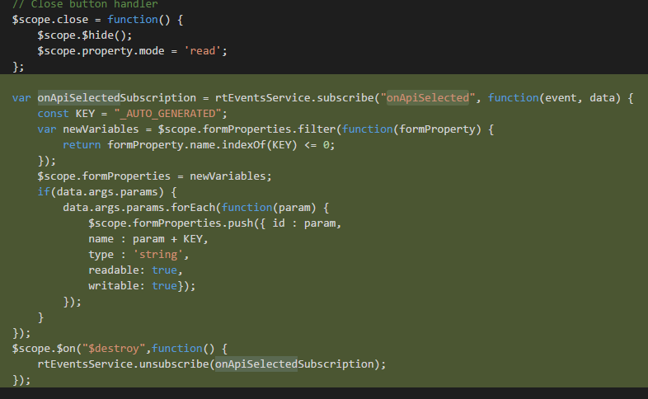

* 1. Added a condition inside **removeProperty** method to publish an event when a property of type **api** is being removed. This will remove all its auto generated parameters automatically.

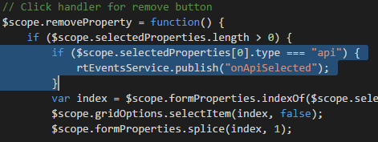

1. Modified save-model.html (**modules\activiti-webapp-explorer2\src\main\webapp\editor-app\popups\save-model.html**) to hide save and close button

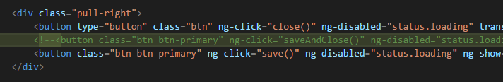

1. Modified **toolbar-default-actions.js**
   1. Injected rtWorkflowApi into SaveModelCtrl

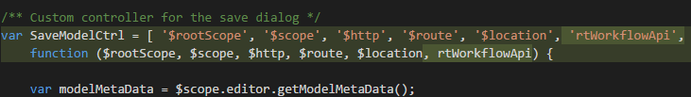

* 1. On save success callback added logic to call updateModel of reactore system

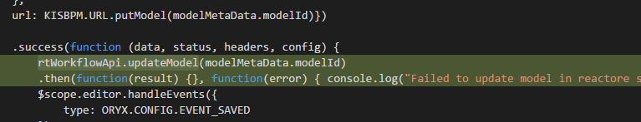

## Deploying activity explorer

The server URLS for common module and workflow needs to be updated to relevant environments in **app-cfg.js** which is located inside the folder **modules\activiti-webapp-explorer2\src\main\webapp\editor-app**

ACTIVITI.REACTORE_CONFIG = {

'DEFAULT_SERVICE_CLASS_NAME': 'com.reactore.workflow.feature.activitilink.RestCall',

'COMMON_SERVER_URL' : 'http://192.168.1.165:90/common/',

'WORKFLOW_SERVER_URL': 'http://192.168.1.165:90/workflow/'

};

**COMMON_SERVER_URL** : "http://192.168.1.165:90/common/";

This URL will be used as the base URL to get modules and entityTypes

**WORKFLOW_SERVER_URL** : "http://192.168.1.165:90/workflow/";

This URL will be used to get the api end points based on selected moduleId and entityTypeId